**GET Request and Response Automation**

Open eclipse and create a maven project

Add the required dependencies in pom.xml file

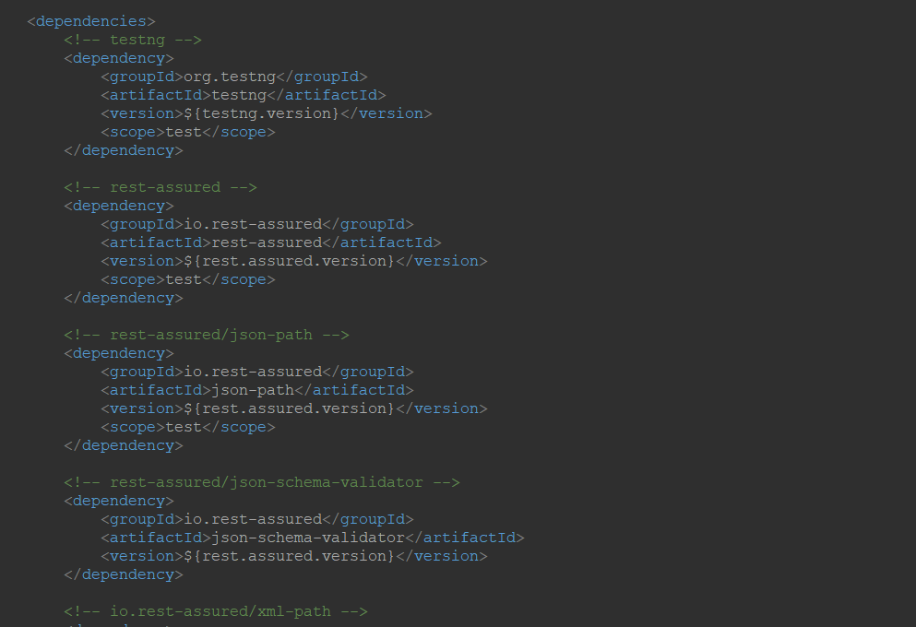

Create a class and add the following code

**package** GetResponse;

import org.testng.annotations.Test;

import io.restassured.RestAssured;

import io.restassured.http.Method;

import io.restassured.response.Response;

import io.restassured.specification.RequestSpecification;

import junit.framework.Assert;

public **class** GetResponse1 {

@Test

void getempDetails()

{

//specify baseUrI

RestAssured.baseURI="http://192.168.1.207:8080/api/employee/search";

//Request object

RequestSpecification httpRequest=RestAssured.given();

//Response object

Response response=httpRequest.request(Method.GET,"/8095393564");

//print response in console window

String responseBody=response.getBody().asString();

         System.out.println("Response Body is:" +responseBody);

//status code validation

int statusCode=response.getStatusCode();

System.out.println("status code is :"+statusCode);

Assert.assertEquals(200,statusCode);

}

}

Run the code using testng

Then you get the result

